**DESIGN AND IMPLEMENTATION OF A STUDENT INFORMATION**

**SYSTEM FOR RESULT CHECKING AND CGPA CALCULATOR**

**BY**

**OLU-AJIMATI VICTOR**

**MATRIC NO: 248222**

**BEING A PROJECT SUBMITTED TO THE DEPARTMENT OF**

**COMPUTER SOFTWARE ENGINEERING, OF**

**HIGHLAND COLLEGE OF TECHNOLOGY, SAMONDA, IBADAN**

**IN PARTIAL FULFILLMENT OF THE REQUIREMENT FOR THE**

**AWARD OF NATIONAL DIPLOMA (ND) IN**

**THE DEPARTMENT OF COMPUTER SOFTWARE ENGINEERING,**

**OF HIGHLAND COLLEGE OF**

**TECHNOLOGY, SAMONDA, IBADAN**

**TABLE OF Contents**

**1.** **GENERAL SCOPE** 3

**LITERATURE REVIEW** 3

• **HISTORY OF STUDENT INFORMATION SYSTEM (SIS)** 3

**2.** **DEFINITION/CONCEPTS EXPLAINED** 5

• **STUDENT INFORMATION SYSTEM (SIS)** 5

• **WHAT IS A STUDENT INFORMATION SYSTEM FOR** 6

**IMPORTANCE OF STUDENT INFORMATION SYSTEM** 6

**RESULT COMPUTING AND CHECKING** 7

**STUDENT RESULT PROCESSING SYSTEM ARCHITECTURE** 9

**IMPORTANCE OF STUDENT RESULT PROCESSING SYSTEM** 10

**CGPA CALCULATOR** 10

**WHEN DID THE CGPA GRADE SYSTEM START?** 10

**HOW TO USE A CGPA CALCULATOR** 10

**STUDENT INFORMATION SYSTEM METHODOLOGY/FRAMEWORK** 11

**METHODOLOGY** 11

**FRAMEWORK** 11

**TOOL** 11

**EXAMPLES OF STUDENT INFORMATION SYSTEM** 12

**UNIQUENESS** 15

**CHAPTER TWO**

# **GENERAL SCOPE**

## **LITERATURE REVIEW**

A student information system (SIS), student management system, school administration software or student administration system is a management information system for education establishments used to manage student data. Student’s information systems provide capabilities for registering in courses; documenting grading, transcripts of academic achievements and co-curricular activities, and the results of student assessment scores; forming student schedules; tracking student’s attendance; and managing other student related data needs in an educational institution.

Information security is a concern, as universities house an array of sensitive personal information, making them attractive targets for security breaches, such as those experienced by retail corporations or healthcare providers.

# **HISTORY OF STUDENT INFORMATION SYSTEM (SIS)**

Over the past few decades, universities all over the world have been experiencing new paradigms in the way they handle and manage students’ information due to the proliferation of ICTs and its applications such as web-based student information systems. With the adoption of such systems as the Online Student Information System (OSIS) in academic institutions, the experience is that it has now become easy to harness and fast track all students’ records in one centralized database via the internet technology. While the benefits of OSIS seem to be cerebrated, it has been a hustle for most universities in Africa to completely go digital in their operations due poor ICT infrastructures that seem to be prevalent in the region. In Malawi, a social survey was conducted with the aim of assessing the Mzuzu University Student Online Management System (SOMS) from the perceptive of students. The study applied the principles of both qualitative and quantitative research approaches. The principal data collection methods were questionnaires and follow up interviews. The study population was made up of third year students in the Faculty of Information Science and Communications and the Director of ICT services at Mzuzu University. The quantitative data collected were analyzed and presented using Microsoft Excel Package. Thematic analysis technique was used to analyze the data collected through interviews. The study revealed that Mzuzu University SOMS has one prime service which is online registration and admissions, with online examination results access, student profile and finance as add-ons. The system benefits students as it has cut the time spent during registration periods in every new semester. Students faced the following major challenges when using the system; server loads as more students.

Swift transitions in the way institutions of higher learning handle and manage students’ information are brought about through technological revolutions, perhaps with the emergence of online student management systems. The concept of Student Management System (SMS) is within a larger field of Information Systems (IS) and it dates back as far early as 1960s (Evangelista, 2011; Marrero, 2009 & Swartz, 2007). Broadly defined, an SMS is “a general information system for maintaining and providing student information and it almost exists in all the schools, colleges, universities and any other education institutions” (Pan, 2004, p.3). Nowadays, SMSs have been described variously as: Student Information Systems (SIS), Student Management Information Systems (SMIS), Student Data Systems (SDS), Student Data Warehouse (SDW), Student Academic Information Systems (SAIS), or Student Information Management Systems (SIMS), Online Student Information System (OSIS) and Student Academic Register Information System (SARIS), (Kaloki, n.d; Maere, 2011 & Paulsen, 2002). Kasozi (2006) noted that despite having various nomenclatures, these information systems serve a similar function and they are all connected to the management of students’ information or records in universities or other educational institutes.

In the pre-digital age, managing student’s information was done manually, using paper-based systems. However, with increasing number of students in educational institutes, the system could no longer handle student’s records effectively. Suffice to say, the dawn of ICT applications and databases presented unparalleled opportunities in managing students’ records in academic institutions which gradually lead to the disappearance of paper-based systems. The major concern with manual systems has been the speed with which business operations and decision making processes are carried out in education institutions. Consequently, to cope up with the rise in student’s enrolment whilst at the same time ensuring efficiency in their operations, universities had to experience a paradigm shift from using manual student’s management systems to online student management systems. Pan (2004) explains that Students Management Systems (SMS) whether manual or online are there to maintain and provide student information in universities and colleges. While specifically, online student information systems depict a centralized virtual database where all information pertaining students are properly stored in an educational institution (Pacio, 2013). Principally, it is used for management of the most pivotal information about entities such as students, faculty, courses, applications, admissions, payment, exams, and grades (Paulsen, 2002).

Bharamagoudar, Geeta and Totad (2013) opines that an effective SMS provides a simple interface for maintenance of student information. It can be used by educational institutes or colleges to maintain the records of students easily. Thus the creation and management of the most accurate, up-to-date information regarding a students’ academic career is of ultimate value to universities as well as colleges. The understanding is that managing student’s records manually comes with a lot of challenges. For instance, most of the times information is littered everywhere, can be redundant, inconsistent and collecting relevant information may be very time consuming (Pacio, 2013) as cited in Richard (2004). This development accelerated an automatic switch to online-based student management systems in most universities across the world with the purpose of maximizing the benefits from its effectivity to acquire, process, store and retrieve information from the Internet.

Concurrently use the system, high cost of internet data bundles and charges, lack of system regular updates and high cost of password recovery. The study recommends that the university through the ICT Directorate should consider addressing the various issues impeding the effective use of the system amongst the student community

# **DEFINITION/CONCEPTS EXPLAINED**

## **STUDENT INFORMATION SYSTEM (SIS)**

A **Student Information System,** or SIS, is a web-based platform that helps schools and colleges take data online for easier management and better clarity.

The SIS system is able to collect school-wide data online so that it can be easily accessed by teachers, parents, students, and administrators. That includes records of tests, attendance, appraisal performance, and plenty more.

Essentially, a SIS allows the school to make data points for lots of areas in one place so that it’s easy to keep track of progress and performance.

## **WHAT IS A STUDENT INFORMATION SYSTEM FOR**

The Student Information System is there to create a self-service solution for students to get their administrative tasks done in one place. Equally, it can support faculty and staff by helping to simplify and integrate work processes.

Student information system provide capabilities for registering students in courses; documenting grading, transcripts of academic achievement and co-curricular activities, and the results of student assessment scores; forming student schedules; tracking student attendance; and managing other student-related data needs.

A student information system helps the admissions department track prospective students during the application and enrollment process. The software also updates the profiles of qualified students with changes as they happen.

## **IMPORTANCE OF STUDENT INFORMATION SYSTEM**

1. **LIBRARY MANAGEMENT**

Student information system keeps track of most important library function – books issued and returned. The library management also tracks other relevant information relating to fines collected, condition of a book, and delay in book returns, students record, etc.

1. **ADMISSION MANAGEMENT**

Admission management with a student attendance management system is easier and more organized as there are multiple tasks that need to be looked after. Manual processes to handle admissions can be tedious and time consuming. Students information, enrollment status, results can be published online for parents and student to view.

1. **STUDENT BEHAVIOUR TRACKING AND ANALYSIS**

Student information system software has predicted analysis tools that provide an insight into student’s behavior. What is does is record students behavior on everyday basis and analyze the effectiveness of different learning methods.

1. **STUDENT RECORD MANAGEMENT**

Similar to managing multiple library processes, student information system for higher education and secondary studies help manage data such as student’s behavioral record, performance, grades, participation in extra-curricular activities, complaints and discipline. All such information can be efficiently uploaded, saved and updated at regular intervals within a matter of few minutes.

1. **CLASS SCHEDULING AND COURSE REGISTRATION**

Online student information system provides a student portal, which can be accessed by students for registering for new courses and checking class schedules easily. Learners can even uses this portal for checking grades, attendance as well as tracking their performance.

1. **PARENT PORTAL**

Student information system software provides a parent portal for their wards performance, attendance and other related information. Secondly, the feature also facilitates open communication between parents and teachers/administration.

## **RESULT COMPUTING AND CHECKING**

In Nigerian Universities, the performance of students is based almost entirely on end-of academic session examinations. Conducting of examination is a crucial and complex job for the University Administration. Absolute confidentiality has to be ensured. The admission of students into various departments of the University has been increasing at an accelerated rate and has now reached a position where it is very difficult for the available manpower to cope with the magnitude of examination work, in the given time span thereby leading to delay in the declaration of session results. An effective measure which can improve the efficiency of the result processing system is the introduction of computerization.

Student’s Examination result is one of the most important elements in schools. These data must be processed under critical management, while requiring simple operations for processing the examination results. The need for student to have access to their result on time and accurately cannot be overemphasized. Scores from examination taken by student need to be returned to these student to enable them know their performance in the various courses written. Also, students need to know what courses they failed in order to retake the exams. Staff in charge of student result processing is burdened with a lot of other academic works like lecturing, research, marking of exams and attending to other administrative task. These other duties tend to affect the timely, efficient and accurate processing of results. The effort expended in the process of registration of students and computation of their examination results is awesome. Quite worrisome is the fact that these processes are carried out every academic session, putting the operators in a continuous and ever demanding cycle.

It seems quite a safe bet to assert that the internet and mobile communication have had a greater influence on the way the world relates today. On the other hand, education remains an essential fact of life for the overwhelming majority of the human society in Nigeria; the educational sector has experienced marked changes as a result of introduction of internet-based services. In one case, results for the UTME( Universities Tertiary Matriculation Examination) are now being processed within days if the examination being written , an ever- increase number of universities are employing the internet to deliver a widening range of information and support services, covering such as areas such as admissions, student registration, examination records and distance learning. This work is an attempt of delivering examination results on demand, using Highland College of Technology as a case study. This application would also provide capabilities to assist students, lecturers and administrative personnel interact in resolving any result-related complaints.

The result checking system not only allows students to request for grades. It provides the result as soon as they are available. This is done by pushing the results th=o the students (sending it to their devices) or work on a request sent from the student to produce the result (pulling).

### **STUDENT RESULT PROCESSING SYSTEM ARCHITECTURE**

Computerized

Result Processing

System

Valid User?

User Name

Password

Student

Information

Y

N

Student

Registration

Student

Mark Sheets

Registered

Students

Process

Student Result

Error Report

Student Result

Compute

Student Result

Raw Score

### **IMPORTANCE OF STUDENT RESULT PROCESSING SYSTEM**

1. To save time and reduce the stress involved in students result processing.
2. To facilitate student’s result processing activities with the aid of a program to give rise to effective production of student’s results with fewer errors.
3. To handle large volumes of processing.
4. To aid in the management in the making of quick and positive decisions.
5. To interpret data of students overall result.

## **CGPA CALCULATOR**

It is the average of the scores of all subjects, or – the scores of all semesters.

For example:

In order to calculate the CPGA of a student who has scored 79, 80, 85, 68, and 91 out of 100 in his five main subjects, we will add the total and divide the result by the maximum marks.

In this example, we will divide 403 by 500 to get the CGPA of 8.06.

Similarly, if CGPA has to be calculated for all semesters of a specific course, the total obtained in all subjects of this course will be added and divided by the maximum marks possible in that course.

### **WHEN DID THE CGPA GRADE SYSTEM START?**

CGPA and other such grading systems have gained worldwide popularity in the late ’90s.  
Before that, the marks scored were the sole criteria to judge a student’s performance.

### **HOW TO USE A CGPA CALCULATOR**

In order to **calculate** your **CGPA**, you need to first find the average score of all subjects in each of the semesters, i.e. **SGPA**. Then, add all the **SGPAs** of all the semesters and divide the total by the number of semesters or sessions to find your **CGPA** for the academic year. **CGPA**= (SGPAs of All semesters in an academic year) / Number of semesters.

**NOTE:** SGPA: SGPA (Semester Grade Point Average) is a grading system used in educational institutions worldwide, which is defined as the weighted mean of the grades achieved in various subjects by the students, wherein each subject is allocated with a particular credit acting as a weight for that subject. SGPA in various countries has slight modifications depending upon the respective educational systems.

# **STUDENT INFORMATION SYSTEM METHODOLOGY/FRAMEWORK**

## **METHODOLOGY**

This **Student** **Information** **System (SIS)** development used RAD (Rapid Application Design) **methodology**. This **methodology** **method** follows the System Development Life Cycle (SDLC) that in a sequential and structured away. RAD is a **methodology** for compressing the analysis, design, build, and test phases into a series of short, iterative development cycles. This has a number of distinct advantages over the traditional sequential development model. Iteration allows for effectiveness and self-correction. Studies have shown that human beings almost never perform a complex task correctly the first time. However, people are extremely good at making an adequate beginning and then making many small refinements and improvements. RAD projects are typically operated with small-integrated teams comprised of developers, end users, and IT technical resources. Small teams, combined with short, iterative development cycles optimize speed, unity of vision and purpose, effective informal communication and simple project management.

## **FRAMEWORK**

The Student Information System is an **understudy information assortment framework** that causes the Department to accumulate and audit more solid and more definite data. Understudy data frameworks can get to understudy records, track understudy participation, and handle numerous other understudy related information principles in schools or colleges.

## **TOOL**

**SchoolTool – web-based student information system**

SchoolTool is an open source school management information system. It is a traditional web application, usable with a web browser. Development of the software was discontinued in 2016, although the source code is still available.

This application is used by schools for a single purpose, by individual teachers or small teams within schools, or as a whole-school comprehensive student information system, encompassing demographics, gradebooks, attendance, calendars and reporting.

SchoolTool is written in Python using the Zope 3 component architecture.

Features include:

* Customizable demographics.
* Student contact management.
* Calendars for the school, groups, and individuals:
  + Person calendars are kept private.
  + ‘Overlay’ events from other calendars on to your personal calendar.
  + Create single or repeating events.
* Resource booking – schedule shared resources via their calendar.
* Teacher gradebooks – create assignments (or ‘activities’) that are organized and may be weighted by category, such as ‘exam’ or ‘presentation’.
* Class attendance – a simple attendance and participation journal.
* Intervention system – to manage an ‘intervention’ meeting between a student and other stakeholders to address disciplinary, academic or other issues.
* Report card generation.
* Internationalization.
* Single-sign on.
* Variety of ways to import and export data.

# **EXAMPLES OF STUDENT INFORMATION SYSTEM**

**PowerSchool SIS**

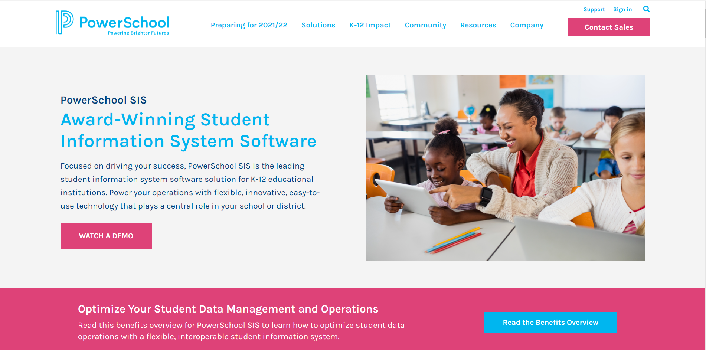

<https://www.powerschool.com/solutions/student-information-system/powerschool-sis/>

**Definition: PowerSchool** is the leading provider of cloud-based software for K-12 education in North America. Its mission is to power the education ecosystem with unified technology that helps educators and students realize their full potential, in their way.

**Skyward**



<https://www.skyward.com/>

**Description:** Skyward applications are currently used by school districts and municipalities in 22 U.S. states and multiple international locations. Skyward's student information system and ERP solutions are designed to automate and simplify daily tasks in the areas of student management, financial management, and human resources.

**Gradelink**

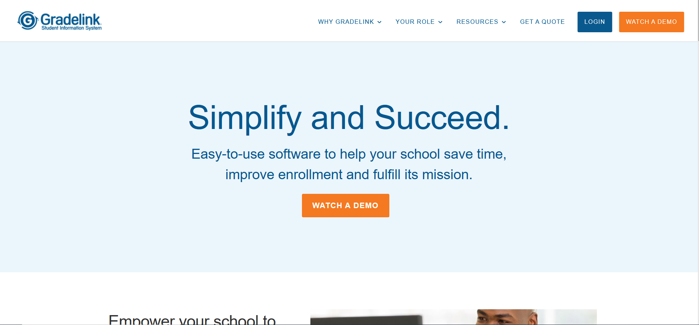

<https://www.gradelink.com/>

**Description:** **Gradelink** is a cloud-based school management solution that helps connect teachers, students and parents through a single interface. Key features include student enrollment management, attendance report generation, grade and attendance tracking and report card printing.

**Infinite Campus**

<https://www.infinitecampus.com>

**Description: Infinite** **Campus** is a place where smart, talented people work with other smart and talented people every day. It’s an environment where people take pride in their craft knowing that what they work on will be used by millions of teachers, students, parents and school administrators tomorrow.

# **UNIQUENESS**

The current method being employed in Highland College of Technology is the manual method of computing students result. This process makes students result computation to be time consuming and prone to errors.

Details from the college about the student, courses and the examination scores and other relevant information will be used to create a database for the system to keep the academic records of the students.

Two access options will be provided, where a user either login as a Chief Examiner/Head of Department or as an Administrator. For the Administrator, one will only be able to enter scores for the course(s) which he/she takes and view the grades. As a Chief Examiner, one will be able to register students, courses and lecturers, assign courses to lecturers, enter examination scores and view the grades, view all students’ results and compute GPA and CGPA. The Administrator will have all the privileges of the other users of the system. Users of the system at the login interface will have to enter their username and password in the text fields as contained in the database. If username and password are valid for respective users as contained in the database, the system menu interface is displayed as related to individual users.